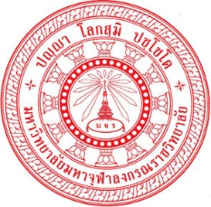 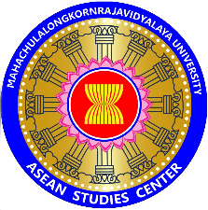 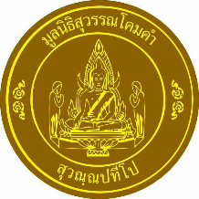
Briefing Report
4th floor Zone D, Room D 424 14:00 – 15:00 p.m. 10 January 2018.
Scholarship Award Ceremony Offered by Suwankhomkham Foundation
Co-project by ASEAN Studies Centre and Student Affairs Division

Great respect to Most Ven. Dr. Phrarajvoramuni, vice rector to Student affair and acting director to Language Institute, Mahachulalongkornrajvidyalaya University
I am Phramaha Somphong Santacitto, Ph.D. acting director to administration, plan and network development, ASEAN Studies Centre, and Student Affair Division together with staff and Foundation of Suwankhomkham led by Dr. Phramaha Yongyuth Diradhammo along with his devotees, (Upasaka and Upasika) who offered scholarship to ASEAN Students and International Students of MCU for this time being.
I would like to make briefing about this project as follow:
This scholarship award has been held by Dr. Phramaha Yongyuth Diradhammo to the underprivileged students in the rural areas for nearly 10 years and later he and his foundation expanded scholarship to ASEAN students and international Students for last 3 years that has been held mostly for the English Program students, B.A. Faculties of Humanities.
As we know, ASEAN Studies Centre has mission to encourage and support the students’ learning activities as well as create the ASEAN networks among students, lecturers, academicians and Buddhist organizations throughout ASEAN countries. Hence, this activity of scholarship award is a starting project activity of this year 2018 for cooperation of ASEAN organization and student’s networks.
The number of scholarship recipient students is 31 persons and covers over 10 countries: Thailand, Lao, Myanmar, Cambodia, Vietnam, Malaysia, Bhutan, India, Bangladesh, Sri Lanka, China, and Russia and they represent their group or organization and this is mainly of objective for better future cooperation and collaboration among students and buddhists. The cost of scholarship is 62,000 Baht totally offered by Suwankhomkham Foundation Members.
For this time being, I would like to kindly call upon Most Ven. Dr. Phrarajvoramuni to present the scholarship to our dear 29 students and give the special lecture on “Development on Student’s Identities of MCU” onwards.
With Great Respect Ven. Phramaha Somphong Santacitto, Ph.D.,
Acting director to administration, plan and network development,
ASEAN Studies Centre

