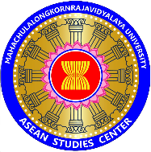
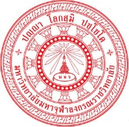
Basic ASEAN Buddhist Photography Course
Workshop: Buddhism and Multi-Culture in ASEAN through Lens
By ASEAN MCU Students Networks facilitated by ASEAN Studies Centre
Buddhametta Room, Fourth Floor, Learning Complex
Week | Date | Contents | Note
Day 1 | 06-02-18 | Introduction  - How to Design Your Idea and prepare yourself before taking shots  - Basic Composition – Aperture, Shutter Speed, ISO | Before photography  -Study  -Practice  -Take-home works
Day 2 | 09-02-18 | Basic Photography  -Composition  - When to use manual  - Low light photography  - Exposure Compensation  - When to use flash | -Study  -Practice  -Take-home works
Day 3 | 13-02-18 | Action Photography  - Event,  - Emotion,  - Movement,  - Sports, | -Study  -Practice  -Take-home works
Day 4 | 15-02-18 | Portraits Photography  - Lights / Skin tone /-Wedding Shots  - -Group Shots / -Self-Portraits  - -Children | -Study  -Practice  -Take-home works
Day 5 | 19-02-18 | Landscapes  - Natural Photography  - Seascapes/ Cityscape/ Landmarks | -Study  -Practice  Take-home works
Day 6 | 20-02-18 | Travel/Street photos  - Aerial Shots  - Culture & Traditions  - Seascapes/Waterfalls /Sunrise/Sunset/Snow | -Study  -Practice  -Take-home works
Day 7 | 23-02-18 | Process:  E-book Reading Publications: Poster, Brochure, Leftover, Banner, leaflet, Booklet. Photobooks. | - Need computer
Day 8 | 26-02-18 | Summary
*All trainees are required to come along with your own camera and computer
This workshop will be open from 6-26-02-2018
All trainees must own their camera-DSLR or Mirrorless

