The Dharmasala Route from Angkor Ta Muan,
Phanom Rung to Phimai
- an ancient route in revival –
The ASEAN Buddhist Seminar on ‘The Royal Route/ La Voie Royale’

Six Provinces: Ayutthaya, Nakhon Ratchasima, Buriram, Surin, Sisaket, Ubol Raj Thani through the three Historical Sites: Phimai, Phanom Rung, Khao Phra Wihan

24-27 March 2018/2561
Granted on 27 March, 2018/2561

ASEAN STUDIES CENTRE
Mahachulalongkornrajavidyalaya University

Foreword

Contents

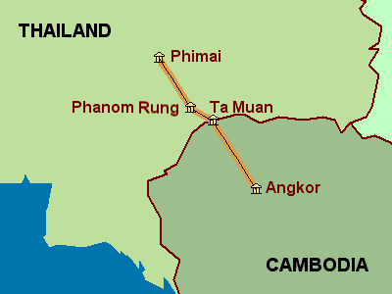
BACKGROUND

The author of this article has since 2003 conducted GPS-based field-research on the orientation of ancient Khmer temples in NE-Thailand (Isan), a research aimed at analysing the general trend in orientation of Khmer sites and eventual celestial relation.
After having completed the research in Buriram Province the author became interested in the routings between the Khmer sites, including ancient settlements, in Isan down to the ancient capital city of Kambuja, Angkor Wat.
The provincial authorities of Buriram were in 2004 very interested in the ancient route as well because it was in a process of being promoted as a 'Cultural Route' including the dharmasalas and the better known temples as Phimai and Phanom Rung. The project was centrally initiated (the National World Heritage Committee at the Office of Natural Resources and Environmental Policy and Planning).
The local authorities had problems locating the dharmasalas in Buriram, especially Prasat Nong Kong, which coordinates were incorrectly given in their FAD material. As the author already had located the site, he was happy to support the vice-governor's office with the correct coordinates, the coordinates of all Khmer sites in Buriram, and a short description of the temples. The paper is hereby also available for the general public, see the article below.
***
 | NEW ASPECTS IN THE PRESENT ARTICLE
1 | The routing from Ta Muan to Phimai is not as hitherto described basically straight, it zigzags from site to site through Isan.
2 | The distances between the sites vary considerably.
3 | The orientations of the constructions vary considerably.
4 | The Hindu temples That Phanom Rung and Muang Tam might be secondary options on the pilgrimage.
5 | The 'Cultural Route' as a tourism project will be in focus the coming year.
***

The Dharmasala Route from Angkor to Phimai
- an ancient route in revival -
A stone-inscription discovered in 1937 at Preah Khan temple at Angkor Thom, informs us that the Mahayana Buddhist emperor Jayavarman VII (1181 – ca. 1220 A.D.) initiated the construction of 121 vahni-griha along routes throughout his kingdom. One route mentioned is the route from Yasodharaphura (Angkor) to Vimai (Phimai), where the number is given to be 17.
Another inscription, from the nearby Ta Prohm temple, tells us about another ambitious plan of Jayavarman VII: The construction of 102 arogyasalas throughout every province of his kingdom.
The Ta Prohm inscription let us know that the arogyasalas were 'hospitals' or rather 'hospital chapels'. But the Preah Khan inscription does not mention the function of the vahni-grihas.
⇩
The only clue we have of the use of the vahni-grihas lies in the term itself, which therefore deserves some considerations:
Coedes translated vahni-griha to French as 'maison avec du feu', 'gîtes d'étape avec du feu' or just ' gîtes d'étape', which in English is something like 'house with fire', 'stopping place with fire', or just 'stopping place'.
Vedic religious architecture operates with a garbha-griha, 'womb-room', which is the small dark room in the central sanctuary, where the principal deity, the god, of the temple is installed. In the term vahni-griha we have the same griha, meaning 'chamber', 'house', 'habitation', 'home' – various forms of 'shelter'. A 'temple' (shelter of the gods) is another lexical possibility. The other compound of the term is vahni, which as an isolated term is given (in Cologne Digital Sanskrit Lexicon) as 'the conveyer or bearer of oblations to the gods (especially said of Agni, 'fire', or of the 'three sacrificial fires'. Vahni also occurs in numerous combined nouns meaning 'fire', as for example in makha-vahni, 'sacrificial fire' – or vahni-griha, 'fire-chamber'. Vahni-sala also means 'fire-chamber', with sala as 'house', 'mansion', 'building', 'hall', 'large room', 'shed', etc.
Fire and the god Agni are lexically closely associated: Vahni-loka is the 'world of Agni'. Agni is still a high-class word for fire in modern Thailand – pronounced ak-kha-ni.
The most proper translations of vahni-griha must therefore be house with fire (or rather temple with fire), fire-chamber, or fire-shelter. Another option is to use vahni-griha as it is written in the original Sanskrit text – or use agni-sala, which has the same meaning.
The vahni-grihas are later described by Zhou Daguan, a Chinese diplomat living at Angkor nearly a year in the end of the 13th century almost a century after Jayavarman VII. Zhou Daguan noted that on "the great routes there are places of rest like our post relays".
The often used term 'rest-house' is problematic as it gives associations to some kind of accommodation for travellers, which is not the case. Stone structures were not shelters for humans. If the structures had a pilgrimage function, then the pilgrims accommodated in perishable shelters made of wood, bamboo and grass.
Temple with fire: Agni means fire in Sanskrit. Agni is also one of the most important gods of the Vedic pantheon, being the god of fire and ritual sacrifice. In later Khmer Hindu iconography Agni is depicted as one of the Guardians of the Cardinal Directions, the Dikpalas, riding a rhinoceros and caretaking the SE-direction. Agni also appears as one of the Nine Celestial Deities, the Navagraha, where he more often rides a ram. Whether Agni is depicted on the navagraha frieze at the Mahayana Buddhist Bayon temple of Jayavarman VII is not evident due to erosion of the image, but rituals dedicated to the worship of Agni (fire) are depicted in the reliefs of the inner gallery of Bayon and at Banteay Chmar's eastern gallery northern wing as well: Agni-hotar (fire-sacrifice).
Another meaning of agni-sala is vajra-dvala, which is a mudra, a hand-position or 'spiritual gesture' when for example meditating. And the Buddha figure depicted on the lintel above the eastern doorway of Prasat Ta Muean exposes the agni-sala or vajra-dvala mudra. The term agni-sala could thereby be related not only to fire-rituals, but to Mahayana Buddhist meditation.
In 1925 the French archaeologist Finot wrote about the vahni-grihas and without any arguments coined the term dharmasala. This term has since become widely used and is correct to the extend that these small sanctuaries were places (sala) for Buddhist conduct (dharma).
Even the author favours terms as vahni-griha or agni-sala, or a translations as 'temple with fire' or 'fire-shelter', the more commonly used dharmasala will be used in this paper. The route from Angkor to Phimai is therefore named the Dharmasala Route.
⇩
Seven of the hitherto eight discovered dharmasalas in NE-Thailand are made of laterite with only the door- and window-frames made of sandstone. The size is relatively small: Approximately 4 by 15 meters. The western part is adorned with a spire. Only the southern wall has windows. A pedestal for a religious image can be found inside the western door. The orientation of the eastern door varies from 50.0º to 97.5º - none of them cardinally, straight 90º east.
Only two of the dharmasalas have been renovated: Prasat Ta Muan and Prasat Huai Khaen. The rest are still in a ruined state. Artefacts are generally missing, but Mahayana Buddha figures can be seen in nearby temporary Buddhist temples near 3 of the sites. Only the western door of Prasat Ta Muen is adorned with a lintel depicting Buddha.
The dharmasalas in Cambodia have not yet been visited by the author [2004], but literature studies show similar architectural lay-out.

Prasat Ta Muan from south-west |  | Prasat Ta Muan from south.
THE DHARMASALA ROUTE
The ancient route from Angkor to Phimai is in the literature often referred to as The Royal Road. In this article it is called The Dharmasala Route, as there maybe were at least two routes from Angkor to Phimai, the Dharmasala Route being the latest.
An older and easier accessible route entered the Khorat Plateau at the 11th century Prasat Bai Baek, which is located exactly on the alignment from Angkor to Phimai. Prasat Bai Baek is like the 12th century Angkor Wat dedicated Vishnu and shares the same unique orientation of straight west, the cardinal direction associated with Vishnu.
The later (12th – early 13th century) Dharmasala Route started at the Preah Khan temple right outside the northern gate of Angkor Thom, where the first dharmasala is located. After passing the flat plain of lowland Cambodia the route crossed the Dangraek Mountains right south of Prasat Ta Muang, which is the first dharmasala on the Khorat plateau.
Jayavarman VII supposedly changed the Phimai-routing to the Ta Muan Mountain Pass some 12 km east of the Sai Taku Mountain Pass at Prasat Ta Muan and constructed a 'rest-house', Prasat Ta Muan and a 'hospital', Prasat Ta Muan Tot, close to the already existing late 11th century Shiva temple, Prasat Ta Muan Thom.
From there the Dharmasala Route was not continuing directly towards Prasat Phanom Rung and Prasat Muang Tam – the 2 most famous temples of a cluster of all together 9 Hindu temples. The route passed the cluster in the eastern perimeter. The 2nd dharmasala on the Khorat Plateau is Prasat Thamo, the 3rd is Prasat Ban Bu, which is the dharmasala closest to and some 4 km east of Prasat Phanom Rung and 4 km north of Prasat Muang Tam.
The Mahayana Buddhist sanctuary Prasat Phimai was the ultimate and final destination for the travelling pilgrims and traders – not Prasat Phanom Rung, which might have been an 'extra option' on the pilgrimage and a detour adding 5 km to the stretch to the 4th dharmasala, Prasat Nong Kong. The presence of a Jayavarman VII 'library' inside the walls of Prasat Phanom Rung indicates that this temple like most other Hindu temples was transformed into a Mahayana Buddhist Temple.
Near Prasat Phanom Rung and at Prasat Muang Tam as well, Jayavarman VII built 'hospitals', arokhayasalas, for curing the maladies of his subjects – but no 'rest-houses' for the pilgrims.

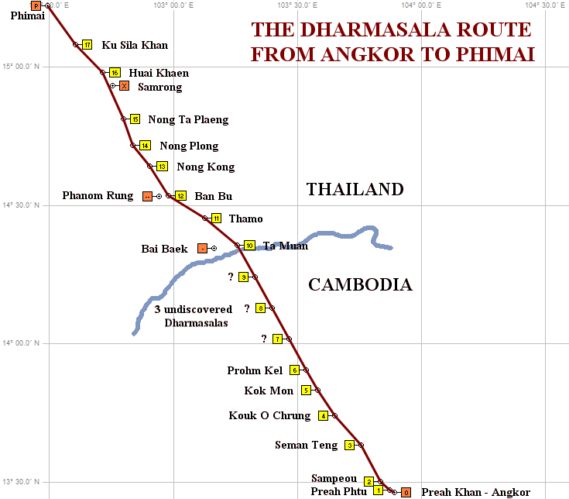
Above: GPS-generated map by the author (2004).
Site 1 - 6 is provided by BEFEO, 10 - 17 is visited, and 7 - 9 are undiscovered.
[2010-note: Site 7 has been identified by a Cambodian team. Site 8 and 9 are still not positively identified and the subject of some controversy among scholars. Site 1, Preah Phyu, is now being questioned as well and is most likely not a Dharmasala].

The route from Angkor to Phimai was first described by the French surveyor E.E. Lunet de Lajonquiere, who on his map depicted it as going straight from Angkor to the Dangrek Mountain Chain. From there the routing was depicted going straight to Phanom Rung and thereafter straight to Phimai.
This straight super-highway concept has since the publishing of Lajonquiere's now nearly 100 years old map been repeated by later scholars.

Right: Map from 1910 made by de Lajonquiere

De Lajonquiére and the temporary French surveyor Aymonier did an excellent job, but neither of them had knowledge of the locations of all 17 dharmasalas, and their mapmaking was done with tools much less accurate than modern equipment.
The here described GPS-survey of ancient Khmer temples in NE-Thailand reveals that the dharmasalas from Phimai to Ta Muan are not located on a straight line - 'like a Roman highway'.
The distance between the locations varies from 11.2 to 20.6 km. After a three weeks motor-bike field research along the alignments of the dharmasalas in NE-Thailand the author does not see any geographic reason for why the Dharmasala Route is zigzagging through the landscape. A further study will include the locations of ancient moated settlements.
This paper consequently uses the term 'route' instead of 'road' because no traces of a paved road has been discovered north of Prohm Kel in Cambodia.
Neither is there any geographic reason for the relatively great variation in distance between the sites. One of the short stretches on 11 km passes 3 rivers and areas pruned to flooding, but the other 11-km stretch passes easily passable flat sandy highland. The longest stretch passes similar easily passable flat sandy highland right south of Phimai, where no ancient settlements are registered and the area was not suitable for rice-growing.
A survey of the 'rest-houses' and stone bridges along the Dharmasala Route in Cambodia has been postponed until after the rainy season, but literature studies (1, 2) reveal that the routing in Cambodia is zigzagging there as well and that there also is variation in orientation of the temples and distance between them.

WHERE ARE THE 17 DHARMASALAS?
Where are the 17 Dharmasalas mentioned in the Preah Khan Inscription? Until this moment [2004] nobody knows the location of all of them!
In the beginning of this year the Fine Arts Department of Thailand (F.A.D.) listed seven Dharmasalas in Isan, then later on eight. Literature studies mention six in Cambodia. The author has received the GPS-addresses of these from the authorities in Phnom Penh and added them on the GPS-generated map above.
Where are the rest then? F.A.D. recently added one in Isan: Prasat Samrong. A short glimpse at the map above does not look convincing. The distance to the next is only 6 km and on flat land easy to travel. The map rather indicates a missing Dharmasala at Phimai (!) – just like there is one right outside Angkor - and at Phimai there actually are two un-excavate sites / candidates.
When surveying Prasat Samrong 7 months ago the ruin did not evidently appear as a Dharmasala, but if F.A.D. is correct, then there are only two missing Dharmasalas in northern Cambodia with a distance between on ca. 20 km – in a rugged landscape, difficult to trespass. A planned future survey in northern Cambodia will hopefully clear out these uncertainties.

THE REVIVAL OF THE ANCIENT ROUTE
The ancient route has come into focus again and is presently being revived. The National World Heritage Committee (the Office of Natural Resources and Environmental Policy and Planning, Bangkok) has in February 2004 prepared and distributed a paper to the provincial authorities setting out guidelines for promoting a 'Cultural Route from Phimai to Ta Muan' (*). This coming route constitutes of a chain of temples on the Khorat Plateau including Prasat Phimai, Prasat Phanom Rung, Prasat Muang Tam , the 8 hitherto discovered dharmasalas and 6 nearby Jayavarman VII 'hospitals'.
An obvious next step would be to expand the route to its cultural centre – Angkor – and several steps in that direction has already been taken.
In May 2004 a caravan with officials from Buriram visited the Jayavarman VII 'hospital' Banteay Chhmar in NW Cambodia and a 'rest-house', Prohm Kel, on the Dharmasala Route. The caravan entered Cambodia at the Chong Sai Taku mountain pass next to Prasat Bai Baek in Buriram province, which presently is only open for locals, but is under preparation to be upgraded to an international checkpoint.
The archaeologists at Prasat Phanom Rung Historical Park works every year on one specific theme. Next years theme is The Cultural Route Angkor-Phimai with emphasis on Buriram.
Another project to be seen next year is the construction of a Cultural Route Information Centre, which will be located at either Phanom Rung or Nang Rong City.
A third related 2005-project is a newly settled group of researchers from Buriram Rajabhat Institute, who will study tourism feasibilities in the triangle Buriram-Srisaket-Angkor with emphasis on The Cultural Route and its associated ancient Khmer temples.
Year 2005 will be the year of the revival of the Cultural Route from Angkor in Cambodia to Phimai in Thailand hopefully strengthening the cultural ties and mutual understanding between the two people.

(*): 'Cultural Route', sen thang ariyatham, (เส้นทางอริยธรรม), could also be translated as the 'Route of Civilization' - as sen thang means 'route' and ariyatham 'civilization'.
(1) Les Points en pierre du Cambodge ancien, Bruno Bruguier, Bulletin de l'École Française d'Extréme-Orient (BEFEO, 2000). (2) Dharmaçalas ou Cambodge, Louis Finot, Bulletin de l'École Française d'Extréme-Orient (BEFEO, 1925).

www.thai-isan-lao.com

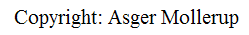

Buriram, 2004 September 12

*** END OF ARTICLE ***

APPENDIXES
1.0 Pictures of Khmer temples in the area along the ancient route(s).
1.1 Dharmasalas in NE-Thailand.
1.2 Jayavarman VII 'hospitals' in NE-Thailand.
1.3 Hindu sanctuaries in NE-Thailand.
1.4 Mahayana Buddhist sanctuary in NE-Thailand.
1.5 Ancient settlements in NE-Thailand.
1.6 Dharmasalas in Cambodia.
1.7 The ancient stone bridge Spean Top (BEFEO: 719) in Cambodia.
1.8 The ancient Khmer stone bridge 'Spean O Kmeng Bridge'.
1.9 Ancient Khmer temples along the northernmost part of Dharmasala Route in Cambodia.
2.0 Links to websites with pictures related to the Dharmasala Route in Cambodia.
3.0 Locations and GPS-position of the 8 dharmasalas of Isan.
4.0 Distances, alignments and orientations.
4.1 The distances and the alignments between the dharmasalas.
4.2 Orientations of the dharmasalas.

1.0. Pictures of Khmer temples in the area along the ancient routes in NE-Thailand:
Dharmasalas, Jayavarman VII 'hospitals', Hindu and Mahayana Buddhist sanctuaries.
1.1: Dharmasalas
No. 17
Prasat Ku Sila Khan,
Khorat Province,
NE-Thailand.
Left: From west
Right: Northern wall
No. 16
Prasat Huai Khaen,
Khorat Province,
NE-Thailand.
Left: From north
Right: Western facade
No. 15
Prasat Nong Ta Plaeng,
Buriram Province,
NE-Thailand.
Left: From S-W
Right: Northern wall
No. 14
Prasat Nong Plong,
Buriram Province,
NE-Thailand.
Left: From west
Right: Northern wall
No. 13
Prasat Nong Kong,
Buriram Province,
NE-Thailand.
Left: From south
Right: Northern wall
No. 12
Prasat Ban Bu,
Buriram Province,
NE-Thailand.
Left: Southern facade
Right: Eastern facade
No. 11
Prasat Thamo,
Buriram Province,
NE-Thailand.
Left: S-E corner
Right: Southern facade
No. 10
Prasat Ta Muan,
Surin Province,
NE-Thailand.
Left: S-W corner
Right: Southern facade

Pictures right and left:
Contemporary Mahayana Buddhist figures in Bayon style can be found on site at Prasat Ban Bu and in several local village temples along the Dharmasala Route

Picture left:
Bayon style amulet found near Prasat Ta Muean.
Picture right: Unknown origin. Meditating Buddha under nagas - with another hair style...
Both pictures: Courtecy to the owner Khun Paitoon Singkasaylit.

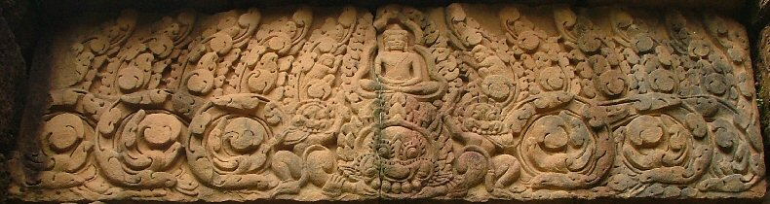
Above: Lintel above the eastern doorway of Prasat Ta Muean

Prasat Samrong (ปราสาทบ้านสำโรง) - a 9th Dharmasala in Isan?
After this paper was edited the Fine Arts Department added a 9th Dharmasala in Thailand - in Buriram province. As mentioned in the article above the author is not convinced.
The argument from a local archaeologist, who was informed about the matter at a recent meeting in Phimai, is that the site has been recently excavated and that artefacts found there indicates Bayon style and thereby Jayavarman VII.
The pictures below are from a research visit early 2004.
Above: Towards what seems to be a door in the western table. The structure is in a very ruined state, |  | Above: In the southern wall there is an opening assumed to be to the remnants of a door.
Above: The base of the northern wall indicates that the temple was a sandstone structure on a laterite base. |  | Above: In the eastern part of the structure, there is a depression like a sump inside the temple.

POSTSCRIPT about Prasat Samrong
A second visit - in October 2004 - revealed that no excavation had been done since April. Local farmers informed that there had been a visit of local dignitaries. And the farmers I met earlier now used the term dharmasala ('thammasala' in Thai) and informed that the temple would soon be 're-build' and that they hoped for tourists to come...
The site was visited again in October 2009 in order to determine the orientation of the ruin more exactly than done in 2004 (right). The sanctuary was still in a ruined state but a road had been constructed to the site.
1.2. Jayavarman VII 'hospitals'.
Kuti Rishi Noi,
Phimai City, Khorat
Left: From west
Right: From SW

Prang Ban Prang
Khorat
Left: From NE
Right: From NW
Under restoration in 2004
Kuti Rishi Nong Boa Lai
Buriram
Left: From east
Right: From NW
Located 3 km east of Phanom Rung south of the large Nong Boa Lai Barai.
Kuti Rishi Ban Khok Muang
Buriram
Left: From east
Right: From east
The site has solar-events coinciding with events at the nearby Prasat Phanom Rung.
Khok Ngiaw
Buriram
Left: From SE
Right: From SW
Located next to the main road from Nang Rong to Pakham

Ta Muean Tot
Surin
Left: From NW
Right: From NW
Located between and close to the Ta Muan dharmasala and Prasat Ta Muan Thom.

1.3. Hindu sanctuaries.
Most of the more than 20 ancient sites, which are located within a distance of 10 km km from the Dharmasala Route are in ruined state. The 7 sites with the highest tourism potential are listed below. The first 5 are are located in a cluster centred around Muang Tam less than 6 km from this. The last 2 are located at the Dangrek Mountain Chain close by the two ancient mountain passes.

Prasat Phanom Rung
Buriram
Early 10th to late 12th century.
Left: Eastern facade.
Right: The setting sun seen through all 15 doors of the temple.
Prasat That Phanom Rung is dedicated Shiva and has a unique location on the top of an extinct volcano. The temple been built in stages over several centuries with the brick towers as the elders construction dating back to the beginning of the 10th century. The central tower and the galleries dates to the era when Suryavarman IV ruled at Angkor.
The temple has in the last years been promoted for the 4 annual solar-events, when the sun penetrates the 15 gates of the temple. The time interval between these events fits with a lunar month and could be an intentionally imbedded calendric feature. For details about the theory on this subject, see the authors web site, or articles in English or Thai.

Prasat Muang Tam
Buriram
11th century
Left: From east.
Right: From NW.

Prasat Muang Tam is another fully renovated Hindu temple dedicated Shiva and located on the plain 6 km SE of Prasat Phanom Rung.
Data form the author's on-going research on astro-archaeology indicates that the temple apparently shares the same astronomical concept as Phanom Rung.

Prasat Plai Bat I
Buriram
Early 10th century
Left: From west.
Right: Jayavarman VII library.

Prasat Plai Bat I is contemporary with the brick towers of Prasat That Phanom Rung and was probably dedicated Shiva. The temple is located on top of an extinct volcano with a higher elevation than the nearby Prasat Plai Bat II, which together with Prasat Phanom Rung and Prasat Muang Tam are clearly visible. The temple is in a ruined state due to treasure hunters use of dynamite.
There are no marked roads or paths up to the site, which is hard to find. Walk-paths up to - and between - Plai Bat I and II will be implemented. The idea is not to spoil the experience of nature- and temple-exploring in a silent environment.

Prasat Plai Bat II
Buriram
10th - 11th century...
Left: From south
Right: Phanom Rung

Plai Bat II is located 1 km west of Plai Bat I and is probably a Hindu temple from the 10th - 11th century. Buddhist artefacts have been excavated from both temples, but these are long gone (sold) and probably dates from later Mahayana Buddhist use of the sites. Some scientists regard the temple as Buddhist.

Prasat Khok Prasat
Buriram
11th century
Left: Towards west.
Right: Detail of Baphuon nagas originally from Prasat Khok Prasat.
Prasat Khok Prasat is located 6 km east of Prasat Muang Dam - and west of the reservoir on the picture. Actually there is no more temple left. Excavations could reveal the laterite foundations and many ornamented sandstones. Many artefacts are now on display in a local school and temple. If minor excavations and renovations were done and the artefacts from the school and the temple were exhibit then a very interesting little 'Baphuon-art museum' could be created next to the ancient reservoir, barai.

Prasat Bai Baek
Buriram
Beg. 11th century
Left: From west
Right: Northern tower from SW

Prasat Bai Baek is a Vishnu temple like the later Angkor Wat with which it also shares the unique orientation of straight west - the cardinal direction associated with Vishnu. A lintel at Phimai Museum depicts Vishnu riding on the mythical bird the Garuda.
The temple is in a ruined state and will probably be given more care in the future due to its location only 800 m from the new bitumen road leading down to the future international checkpoint Sai Taku 2 km SE.

Prasat Ta Muan Thom
Close to Ta Muen in Surin
Late 11th century
Left: From NW
Right: Natural rock-linga

Prasat Ta Muang Thom is a Shiva Temple built in late 11th century and is located right on present Thai-Cambodian border facing south. Descending the stairs from the central sanctuary one descents to the Cambodian plain. The exact location of the border is in dispute and so is ownership of the site, which has put an end to an up-started restoration by the Fine Arts Department of Thailand.
The temple is built around a natural stone linga, which was a highly revered religious among the ancient Khmer. The presence indicates the the temple might be older than the present structure - and so might the ancient route be. Maybe the formulation about which route is the oldest is wrong itself. Maybe both routes were in use simultaneously since pre-historic times.

1.4. Mahayana Buddhist sanctuary:

Central sanctuary from SW | Jayavarman VII as Buddha | Central sanctuary from east
Prasat Phimai dates back to late 11th century and Jayavarman VI and construction continued in the 12th century. In an era when when major Hindu temples were built in the area from Angkor to Phanom Rung, Phimai was primarily dedicated Mahayana Buddhism.
An inscription mentions the installation of the ''Tantric Mahayana god Trailokyavijaya, who attempts to convert the Hindu god Shiva to his form of Buddhism'' (Freeman, 1996). Vajrasattva is carved on a pilaster carrying his vajra (thunderbolt), but rather more as the original weapon of Indra than as the meditation tool in Vajrayana Buddhism.
Together with Bodhisattvas from the Mahayana Buddhist pantheon, Hindu gods Shiva, Krishna, Indra, and various guardians of the cardinal directions are depicted as well. This tolerant religious coexistence has been a characteristic for earlier Hindu monarchs as well as for the later Mahayana Buddhist ruler Jayavarman VII.

1.5. Ancient settlements:
Ancients settlements must be a part the study of ancient travelling routes. The ancient communities traded with one another resulting in a net of local roads/paths. Waterways would most probably have been given priority - when existing.
And we should consider basic questions, such as: Who did travel over longer distances and for what purpose? Merchants and pilgrims would travel - and for each their reason. Military personnel, soldiers, would have had a third reason. Pleasure-travel (tourism) is out of the question - even nowadays many - especially the elder generations - never or seldom leave their province.
Moated sites: Human settlements surrounded by moats and earthen dikes can still be traced in the landscape of southern Isan and Cambodia and can be dated back to pre-historic times the beginning of the 1st millennium. This type of settlements have been studied since the II World War and are well documented in the literature (Moore, Sorachet, Thiwa et. al.).
Three such sites have come into focus under the field-research because of their location close to the direct alignment between dharmasala no 14 and 15 - Prasat Nong Ta Phlaeng in Buriram and Prasat Huai Khaen in Khorat province:
1) Ban Phothairin Phatthana, Buriram: The dike system is renovated and clearly visible in the landscape. The distance to the 'dharmasala alignment' is app. 0.7 km.
2) Ban Samrong Kao (Old Samrong), Buriram: The traces of a large flat stone platform in the village has been measured. The village is believed to be the related to the ancient Khmer temple Prasat Samrong 0.6 km to the south. The ancient Samrong community had 3 encircling moats and dikes. The distance to the 'dharmasala alignment' is app. 1.5 km.
3: Ban Muang Fai - Ban Prasat Thong - Ban Khu Muang village-cluster, hereafter called Muang Fai: The settlement has 5-6 ancient temples located within a radius of 600 m. The distance to the 'dharmasala alignment' is app. 3.5 km.
The French surveyor E.E. Lunet de Lajonquiere visited Muang Fai and published the finding of an ancient square site called Kuti Fai located in Muang Fai in 1907 A.D. in Inventaire Desciptive des Monument Du Cambodge.
Dating the sites in Muang Fai seems impossible due to the poor state of the plundered sites.
Prasat NN, which is made entirely of bricks resemble brick towers such as Prasat Thong, Plaibat II and other Baphuon brick towers from the 10th century. The other sites all have remnants of laterite blocks, sand stones and bricks indicating that these constructions predate Jayavarman VII (late 12th - beginning of the 13th century).
The community itself probably dates much further back. The religious landscape is mixed: A yoni at the museum indicates Saivism, and various Buddhist schools are represented evidenced by the discovery of Dvaravati as well as Mahayana figures.
Religious images can change location, buildings not (or seldom). But the presence of Dvaravati Buddha figures strongly indicates that this religion was practiced at Ban Fai in the 7th century. Maybe Hindu Saivism followed; maybe both were practiced side by side as seen elsewhere. We must anyway assume that both were replaced by Mahayana Buddhism in the era of Jayavarman VII.

Left:
Model of Muang Fai at Muang Fai Community Museum
Right:
Moat and dike in Ban Khu Muang (the 'Dike Community Village')

Figure: GPS-generated map with later hand drawings.
From Prasat Nong Ta Plaeng and north the dharmasala route would have to cross 2 small rivers. When the dharmasalas were built the area already hosted at least 3 moated settlements, most likely connected by roads/tracks and associated bridges.
QUESTION: Would the dharmasala-route constructors make a direct lining and thereby need to construct 2 new bridges - one of them only 800 m from an existing one? Or would the routing have departed from Nong Ta Plaeng following the old buffalo-track marked on the figure above with green, visit Muang Fai with its 5-6 ancient temples (3) and pass two bridges and (1) and continue north? It would add nearly 2 km to a stretch, which already is the longest of the 8 stretches on the Khorat Plateau - 20.6 km.

Searching for traces of an ancient stone-bridge along the straight alignment between Prasat Nong Plong to Prasat Ta Plaeng, Buriram, NE-Thailand.

1.6: Pictures of dharmasalas in Cambodia
Above: 'Dhammasala no. 0' - at Prah Khan, Angkor, seen from south

Left: Eastern front of 'Dharmasala no. 0' at Angkor

Rigth: Western front of Prasat Ta Muan on the Khorat plateau

Left: Interiour from 'Dharmasala no. 0' at Angkor

Rigth: Interiour from Prasat Ta Muan on the Khorat plateau.

Dharmasala no. 6:

Left: Prasat Prohm Kel from south-west
Rigth: Prasat Prohm Kel from south

Left: Eastern front of Prasat Prohm Kel

Rigth: Interior from Prasat Prohm Kel

1.7. The ancient stone bridge Spean Top (BEFEO: 719)
Above: Spean Top Bridge
Right: The relationship between the orientation of the bridge, the dharmasala and the Dharmasala Route orientation.

Above: Details from the bridge: A 3-headed naga flanked by Garudas in the corners. Note the 8-petaled lotus. Presumable Angkor Wat style.

1.8 The ancient Khmer stone bridge 'Spean O Kmeng Bridge'
Notes from a 6-hour initial research-trip in late November 2004.
Above: The positions were based on map-readings and estimations about where it would have been most convenient to build a bridge. |  | Above: GPS-based map made after field research. The location of the bridge was 680 west of estimated position.

Right and below:
'Spean O Kmeng Bridge' (my name)
O Spean Khmeng means 'Khmeng-bridge River' and the name itself indicates the presence of an ancient/old bridge somewhere.
The bridge is made of laterite and is app. 3 m high, 4 m wide and 30 m long and crosses the river in an east-western direction. The river/creek is seasonal and was already dry when visited late November 2004.
1.9 Ancient Khmer temples along the Dharmasala Route in NW-Cambodia.
Prasat Korp Kong is located 9 km west of Phum Samraong (Samrong) town on Route 69, which leads to the more well-known Prasat Banteay Chmar some 50 km from Samrong. Prasat Korb Kong is located 100 m north of Route 69 and consists of a moated site in a very ruined condition. A short inspection of the totally overgrown site only revealed parts of a laterite wall and a piece of Ban Kruat style earthenware, presumably dating to the 10-11th century - and definitely pre-Bayon and thereby older than the dharmasalas of Jayavarman VII. The numerous Ban Kruat kilns are located on the Khorat Plateau 40 km NW of Prasat Korb Kong and pottery for there were traded along the various ancient routes.

Route 69 crosses the O Spean Khmeng Riverapp. 400 m before arriving to the Tonle Sa Lake.

Above: Tonle Sa Lake |  | Above: An ancient Khmer pedestal
A square reservoir like the Tonle Sa Lake (literally the 'Oceanic Reservoir') measuring app. 180 by 370 m and oriented straight E-W) indicates the presence of a pre-Bayon sanctuary: The ratio of the dimensions is app. 1:2. The orientation is equinoctial, meaning that the sun rises aligned with the structure: An observer standing mid western bank will on equinox morning observe the sun rise from mid eastern bank).
The presence of a square pedestal standing at the roadside is second indicator of a nearby temple. Standing alone at the roadside it gave the impression of 'being to late for the bus' or rather being left behind by thieves having no more space on the truck. On top of the pedestal there are 9 small holes for placing auspicious objects, typical for pre-Bayon pedestals.
Asking in the small grocery shop next to we were informed that 50 m south of the shop there are 2 more pedestals on the remnants of a small moated temple.
Above: 'Prasat Tonle Sa' (my name) is located 100 m south of Tonle Sa Lake

Left and right:
A yoni-type Saivite pedestal at Prasat O Spean Khmeng (my name).
Above: Prasat O Spean Khmeng (my name) is located 150 m S-W of the O Spean Khmeng stone bridge and is like the two previously visited surrounded by moats on all sides and again in a totally ruined and overgrown state. Our 2 local guides refused to leave the walk-path due to the danger of land-mines. So all we observed was a yoni-style pedestal probably used for hosting a lingam, Shiva's phallic symbol. This and especially the shape of the square moated site indicates that Prasat O Spean Khmeng too is a pre-Bayon sanctuary and not a dharmasala from the reign of Jayavarman VII, who was a fervent Mahayana Buddhist.

Phum Khpous village is located app. 10 km N-N-W of Phum Tonle Sa village and the presence of another rectangular reservoir made us stop in the modern Buddhist temple at the western side of the reservoir - the normal location of an associated ancient Khmer temple.  The reservoir measures app. 110 by 190 m, it is oriented straight east and is most probably an ancient Khmer baray.  In the temple compound we found a pedestal of unknown age and a dozen sema stones (border stones) of more recent age. |  | 'Prasat Khpuos' or rather: its associated baray  Above: GPS-generated map

Above: Baray Khpous | Above: Sema-stone | Above: Pedestal
The contemporary Buddhist temple has most probably replaced an ancient Khmer site and the Dharmasala Route most probably passed the sanctuary and crossed the seasonal creek at either of the two bridges shown on the map above. The direct alignment between the O Spean Khmeng stone bridge and dharmasala no. 10, Prasat Ta Muan, runs only 40 m west of the bridges.
The presence of three pre-Bayon sanctuaries between the O Spean Khmeng stone bridge and Kouk Khpous Village indicates that the Dharmasala Route was in use in the centuries before Jayavarman VII, late 12th - beg. 13th century.
From Kouk Khpous Village the shortest route to Prasat Phanom Rung is ascending to the Khorat Plateau at Sai Taku Mountain Pass 21.2 km NW at Prasat Bai Baek and the nearby Ban Kruat kilns, but the Dharmasala Route of Jayavarman VII continued N-N-E to Prasat Ta Muan, 14.8 km away (as the crows fly). This distance is so close to the average distance between the dharmasalas in Cambodia (13.2 or 14.9 km - depending on the number of sites), that one with good reason could expect 'Dharmasala no. 9' to be very close by.

But time was running out. We had agreed on a 6-hours research trip, as my Khmer-interpreter had to attend a meeting in Seam Reap. A last-minute tip on another temple in the forest south of the village had to be postponed because a visit would have to be performed by ox-chart and local guides due to land mines. A pity, as the description of the location matched with an estimated location along the GPS-alignments.
Next trip: With my Khmer-interpreter and on two good dirt-bikes dharmasala no. 9 will be found in one day. And within a week no. 8 and 7 as well.
 | On Route 68 to Seam Reap we made a short stop at another ancient route: Angkor - Sa Kaew (Thailand) some 10 km before Route 6 (Siem Riep - Aryan Prathat).
Above: The ancient dike/canal towards west |  | Above: The ancient dike/canal towards east

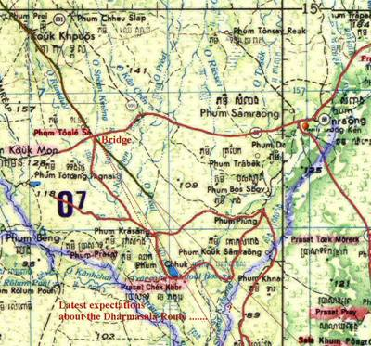

2.0: Links to websites with pictures related to the Dharmasala Route in Cambodia
2.1.1. A Guide to the Angkor Monuments, by Maurice Glaize: Download the book (PDF).
2.1.2, A Guide to the Angkor Monuments: Preah Khan.
2.2.1. Art and Archaeology: Angkor sites.
2.2.2. Art and Archaeology: Dharmasala ''no. 1'', at Preah Phan.
2.3.1. Angkor Ruins: Index - a comprehensive collection of photos from many sites.
2.3.2. Angkor Ruins: Hospital Chapels and Dharmasalas.
2.3.3. Angkor Ruins: The royal Road and Stone Bridges.
2.3.4. Angkor Ruins: Speak Memai Bridge.

3.0: Locations and GPS-position of the 8 known dharmasalas in Thailand
Name of site | Village | Sub-district | District | Province | Latitude | Longitude
ชื่อแหล่ง | บ้าน | ตำบล | อำเภอ |  | (north) | (east)
Ku Sila | Ku Sila | Ku Sila Khan | Lung Pradu | Khorat | 15.07995 | 102.60320
กู่ศิลา | กู่ศิลา | กู่ศิลาขันธ์ | หลุ่งประดู่
Huai Khaen | Huai Khaen | Huai Khaen | Huai Thalaeng | Khorat | 14.98009 | 102.60320
ห้วยแคน | ห้วยแคน | ห้วยแคน | ห้วยแถลง
Nong Ta Pleng | Nong Ta Pleng | Chophaka | Chamni | Buriram | 14.81253 | 102.79719
หนองตาเปล่ง | หนองตาเปล่ง | ช่อผกา | ชำนิ
Nong Plong | Nong Plong | Chamni | Chamni | Buriram | 14.71825 | 102.83619
หนองปล่อง | หนองปล่อง | ชำนิ | ชำนิ
Nong Kong | Nong Kong | Nong Kong | Nang Rong | Buriram | 14.64228 | 102.90576
หนองกง | หนองกง | หนองกง | นางรอง
Ban Bu | Bu | Chorakhae Mak | Prakhonchai | Buriram | 14.53379 | 102.97935
บ้านบุ | บุ | จระเข้มาก | ประโคนชัย
Thamo | Lahansai Kao | Hin Lat | Ban Khruat | Buriram | 14.45452 | 103.12687
ถมอ | ละหานทรายเก่า | หินลาด | บ้านกรวด
Ta Muean* | Nong Khan Na | Ta Muan | Phanom Dong Rak | Surin | 14.35586 | 103.25847
ปราสาทฅาเมือน | หนองคันนา | ฅาเมือน | พนมดงรัก
*: Alternative names for Ta Muean: Ta Muan, Ta Moan, Ta Muen, Bai Khrim.
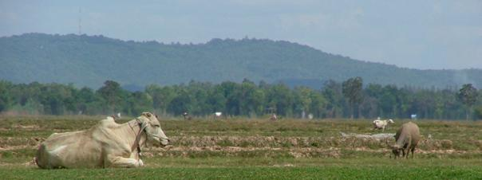
Phanom Rung seen from Prasat Nong Kong

4.0: Distances, alignments and orientations:
The distances between the dharmasalas and the orientations of the dharmasalas itself vary considerably.

4.1. Distances and alignments between the dharmasalas:
From site to site | Distanceท | Alignmentท
Ta Muan to Ta Mo | 17.786ท | 307.6
Ta Mo to Ban Bu | 18.132ท | 298.9
Ban Bu to Nong Kong | 14.634ท | 326.6
Nong Kong to Nong Plong | 11.243ท | 318.3
Nong Plong to Nong Ta Plaeng | 11.227ท | 338.1
Nong Ta Plaeng to Huai Khaen | 20.587ท | 334.0
Huai Khaen to Ku Sila | 16.171ท | 313.0
Ku Sila to Phimai Southern Barai | 16.163ท | 318.9
NB: The distances are in km and the alignments in true bearings.

4.2. Orientations of the dharmasalas:
Under preparation...
END of APPENDIXES

2007 update
In 2004 a Cambodian team found 'Dharmasala no. 7' (Prasat Ampil?).
In 2006 A Thai team (Living Angkor Project) found 'Dharmasala no. 8' (Prasat Kok Phnov?) and after visiting the well-known Prasat Chan some 2 km south of the Thai-Cambodian border tentatively suggested that it might be 'Dharmasala no. 9').
On the GPS-based map to the right Dharmasala 1 to 7 are mapped based on GPS waypoint received from BEFEO, Phnom Penh. The locations in Thailand are from field research in 2004.
Dharmasala no. 8 and 9 are my estimations based on the location of Dharmasala no. 7, the O Spean Khmeng stone bridge (see above) Ta Muan - and on information from a villager in Phum Khpous Village (see above) about a site app. 1 hour by ox-cart south of the village.
A qualified guess of the approximate locations are:
08: N14.20878 E103.37544
09: N14.32233 E103.27083

2010 update
Needed! And coming... | Above: Location of Dharmasalas along the Dharmasala Route (the so called 'Royal Road').

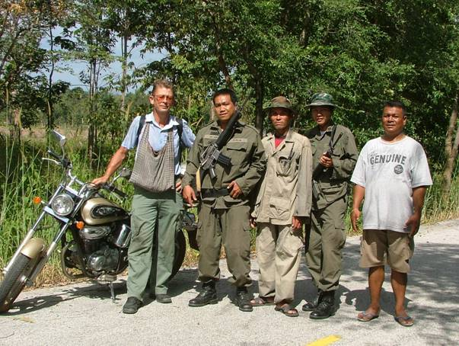
The author and local guides at the Cambodian border
north of Prasat Sdok Kok Thom, Sra Kaew,
in search of the Eastern Route.

INDEX
Last Update: 12 April 2010
macsida@thai-isan-lao.com
www.thai-isan-lao.com

Phimai Historical Park

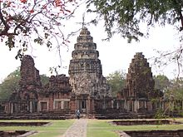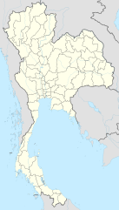

The Phimai historical park (Thai: ปราสาทหินพิมาย) protects one of the most important Khmer temples of Thailand. It is located in the town of Phimai, Nakhon Ratchasima province.
The temple marks one end of the Ancient Khmer Highway from Angkor. As the enclosed area of 1020x580m is comparable with that of Angkor Wat, Phimai must have been an important city in the Khmer Empire. Most buildings are from the late 11th to the late 12th century, built in the Baphuon, Bayon and Angkor Wat style. However, even though the Khmer at that time were Hindu, the temple was built as a Buddhist temple,^{[1]} since the inhabitants of the Khorat area had been Buddhists as far back the 7th century. Inscriptions name the site Vimayapura (which means city of Vimaya), which developed into the Thai name Phimai.
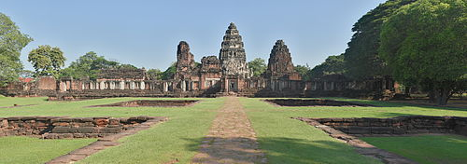
The first inventory of the ruins was done in 1901 by the French geographer Etienne Aymonier. The site was put under Thai governmental protection by announcement in the Government Gazette, Volume 53, section 34, on September 27, 1936. Most of the restorations were done from 1964 to 1969 as a joint Thai-French project. The historical park, now managed by the Fine Arts Department, was officially opened by Princess Maha Chakri Sirindhorn on April 12, 1989.
In the aftermath of the fall of the Ayutthaya Kingdom in 1767, attempts were made to set up five separate states, with Prince Teppipit, a son of King Boromakot, attempting to establish Phimai as one, ruling over eastern provinces including Nakhon Ratchasima. As the weakest of the five, Prince Teppipit was the first to be defeated and was executed in 1768. Phimai had previously been an important town at the time of the Khmer. The temple Prasat Hin Phimai, located in the center of the town, was one of the major Khmer temples in ancient Thailand, connected with Angkor by an ancient Khmer Highway, and oriented to face Angkor as its cardinal direction. The site is now protected as the Phimai Historical Park.
Phimai has recently been the base of operations for the excavation of Ban Non Wat.

Contents

- 1Khmer influence
- 2Within Phimai’s wall
  - 2.1Architecture Style
  - 2.2Construction Materials
- 3Archaeological Projects
- 4Gallery
- 5References
- 6Bibliography
- 7External links

Khmer influence
Because of its location deep in the northeastern part of Thailand, which was once ruled by the Khmer (modern day Cambodia), Phimai’s architecture and cultural decorations are heavily influenced by Khmer culture. Art and architecture shown on the temple itself shows great evidence of the ancient Khmer civilization. Similar in its look and design to Angkor, it also has the same function for worshiping the gods in the Hindu religion.
Despite the fact that Phimai was built in a similar fashion to Angkor and other Khmer Buddhist temples, the religious origin of some structures within Phimai’s walls are still debated. Evidence of Dvaravati influence, such as the sculpture of "the Wheel of Law" or the statue of Buddha, shows that Phimai was an important Buddhist spiritual location. Although a large quantity of Buddhist artwork has been uncovered in Phimai, evidence including the large pots that were embedded in some corners of the structure suggest that spiritual practices other than Buddhism were also practiced in Phimai. Phimai thus has been an important religious landmark for Animists, Buddhists, and Hindus.
There is little evidence concerning the origins of Phimai or the Khmer civilization in Thailand. The earliest engraved records of the Khmer date from the 6th century AD in the northeast of Thailand. For example, stone Sanskrit inscriptions were found along with statues and engraved images of Hindu deities, such as the image of Shiva’s bull Nandin. The king during that time, Mahendravarman, ordered his men to obliterate the engraved inscription. Modern scholars debate about the possibility that evidence may have been lost.
Phimai, along with other Khmer-influenced temples in Thailand, were built mainly under the cause of the "Deveraja cult," or "the King that resembles a god." Jayavarman II was the most mentioned "devaraja." The Devaraja cult developed the belief of worshiping Shiva and the principle that the king was an avatar of Shiva. Under this principle, Khmer rulers built temples to glorify the reign of the king along with the spread of Hinduism.
The 10th century was the time of the reign of king Rajendravarman II (944-968 AD), which was also a time when Khmer control was spreading into what is now northeastern Thai territory. Consequently, temples in Thailand with the Kleang and Baphuon styles remain as evidence of this Khmer heritage. These structures shared the same signature of having three brick towers on a single platform, for instance the Prasat Prang Ku in Si Saket province and Ban Phuluang in Surin province.
Each individual building has its own special features or functions. For example, Prang Brahmadat was built of laterite blocks that form a square. Or Prang Hin Daeng which translates to "Red Stone Tower" which is also a square but was made of red sandstone. Or the main sanctuary built of white sandstone that is almost 32 meters long. The southern lintel has a statue of Buddha meditating with "seven hoods of naga Muchalinda." Adjacent to this is a collection of statues of devils and animals depicted from the Tantric Mahayana Buddhist scripture.
Today Phimai is a well-known tourist attraction, especially among people interested in history and archaeology. Located in the middle of Phimai is a small rectangular gallery surrounding the courtyard, which has been newly rebuilt. Within the gallery there is a pre-Angkorean Buddhist inscription that tells the story of prince Siddhartha Gautama and his journey to becoming Buddha, along with other classic Buddhist stories. The prang symbolize that the area is a sacred space.

Within Phimai’s wall
When tourists enter the area of Phimai from the old town on the south, they have to cross a river about one kilometer to the south and enter an ancient laterite landing stage which archaeologists believe stood for the bathing place for the heroine in local myths. The north gate is the city main gate, also known as the "Pratu Chai," which has recently been reconstructed by the Royal Fine Arts Department. Its size is enormous; it is said that the size is big enough for a royal elephant to enter. The Royal Fine Arts Department also built an inner gallery which shows ancient Buddhist inscriptions and small sculptures as well as pieces of wrecked architecture. The rest of Phimai remains the same only with a little restoration by the Royal Arts Department.

Architecture Style
Having a lot in common with Angkor Wat, Phimai is an example of classical Khmer architecture. Ancient Khmer architects were best known for their superior use of sandstone over the traditional bricks and laterite architectures. Sandstone is used on the visible outer layer. Laterite on the other hand was used for the inner wall and other hidden parts. All the structures are huge sandstone blocks. There are many lotus-shaped roofs representing Mount Meru (Hinduism's holy mountain).
Khmer temples in general, as well as Phimai in this case, were intended to resemble the universe. The main building resembles the peak of Mount Meru at the center of the universe. The surrounding walls resemble the water and encircling mountains. The Khmer did not develop the technique of true vault architecture during their time, results in large areas at Phimai that could not be roofed over. They instead developed the use of multiple chapels separated by open-air spaces.

Construction Materials
The Khmer learned how to use bricks, sandstone, and laterite effectively. They were the three principal structural materials. Builders generally cut the lintel at 45 degrees to produce a triangular wedge.

Archaeological Projects
In 1998, the Origins of Angkor Project (OAP), a joint project of the Royal Thai Fine Arts Department, Anthropology Department, and the University of Otago, New Zealand, began excavations to investigate the underlying sequence. Temple construction during the Angkorian period involved the deliberate deposition of layers of fill, which can clearly be seen in the stratigraphy of the site. ^{[2][3]}

Gallery
- 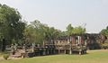
The Naga Bridge, leading to the southern outer gopura

- 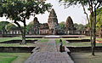
The inner enclosure seen from the southern outer gopura

- 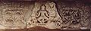
Lintel over the northern entry to main shrine, showing dancing Vajrasattva

- 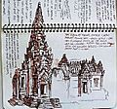
pen and ink sketch

- 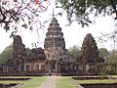
The people looking at the photographer are looking in the direction of Ankor

- 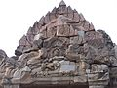

- 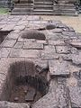
column foundations?

References
  - Jump up^ UNESCO World Heritage Centre. "Phimai, its Cultural Route and the Associated Temples of Phanomroong and Muangtam". Whc.unesco.org. Retrieved 24 December 2014.
  - Jump up^ Talbot, Sarah; Chutima, Janthed (Fall 2001). "Northeast Thailand before Angkor: Evidence from an Archaeological Excavation at the Prasat Hin Phimai" (Journal). Asian Perspectives 40.2. Project MUSE. pp. 179–194. doi:10.1353/asi.2001.0027. Retrieved 29 July 2011. Abstract: Northeast Thailand (Isan) was incorporated into the polity of Angkor around the end of the first millennium AD. Well before this time, local communities in the Phimai region had adopted important activities such as the use of inscriptions and the construction of religious architecture in permanent materials. In 1998, the Origins of Angkor Project undertook an archaeological excavation at the most important Khmer temple in Thailand, the Prasat Hin Phimai. The excavation recovered late prehistoric ceramics and remains of an early brick structure, probably religious in nature, which had been re-used as part of the foundation of the sandstone Angkorian temple.
  - Jump up^ "Northeast Thailand before Angkor: evidence from an archaeological excavation at the Prasat Hin Phimai" (Web). Introduction. HighBeam Research. September 22, 2001. Retrieved September 21, 2011.

Bibliography
- Michael Freeman - A guide to Khmer temples in Thailand and Laos, ISBN 0-8348-0450-6

External links

- - Computer model of the temple
- "Phimai Historical Park detailed description with pictures and video" from "Thai-Thaifood"
- "Phimai Historical Park" in Korat Magazine

Phanom Rung Historical Park
From Wikipedia, the free encyclopedia
Phanom Rung Historical Park
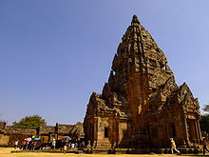
Location in Thailand
Geography
Coordinates | 14°31′57″N 102°56′30″ECoordinates: 14°31′57″N 102°56′30″E
Country | Thailand
Province | Buriram
Culture
Sanctum | Shiva
Architecture
Architecture | Khmer
History
Date built | 10th–13th centuries
Phanom Rung (Thai: พนมรุ้ง, pronounced [pʰānōm rúŋ]), or full name, Prasat Hin Phanom Rung (Thai: ปราสาทหินพนมรุ้ง – Phanom Rung Stone Castle), is a Hindu Khmer temple complex set on the rim of an extinct volcano at 402 metres (1,319 ft) elevation, in Buriram Province in the Isan region of Thailand at the time when Khmer social-political influences were significant in Srisaket. It was built of sandstone and laterite in the 10th to 13th centuries. It was a Hindu shrine dedicated to Shiva, and symbolises Mount Kailash, his heavenly dwelling.
Thailand's Department of Fine Arts spent 17 years restoring the complex to its original state from 1971 to 1988. On 21 May 1988, the park was officially opened by Princess Maha Chakri Sirindhorn.^{[1]} In 2005, the temple was submitted to UNESCO for consideration as a future World Heritage Site.

Contents
- 1Architecture
- 2Phra Narai Lintel
- 3References
- 4External links

Architecture[edit]
After the three-leveled lower stairway is the first cruciform platform, giving a first peek at the main temple. On the right, northward, is Phlab Phla or the White Elephant House. The pavilion is believed to be the place where kings and the royal family would change attire before rituals. Royalty would then enter the processional walkway, one of the most impressive elements of the park. It is 160 meters long and bordered by seventy sandstone posts with tops of lotus buds. The walkway itself is paved with laterite blocks.
The walkway leads to the first of three naga bridges. The five-headed snakes face all four directions and are from the 12th century. This bridge represents the connection between heaven and earth. The naga bridge leads to the upper stairway, which is divided into five sets. Each set has terraces on the sides. The last terrace is wide, made with laterite blocks. It has a cruciform shape and four small pools. A couple more steps lead to the second naga bridge. It has the same shape as the first one, only smaller. In the middle the remains of an eight petalled lotus carving can be seen.
This final terrace leads to the outer gallery. It probably used to be a wooden gallery with a tiled roof, but only a raised floor of laterite remains. After the outer gallery one reaches the inner gallery, which is divided in long and narrow rooms. It served as a wall around the principal tower. This last gallery leads to the third and last naga bridge, another small copy of the first one.
The bridge leads directly into the main sanctuary. After the antechamber and the annex, one reaches the principal tower. Double porches lead out in all directions. The inner sanctum used to have the "linga", the divine symbol of Shiva. Currently, only the "somasutra" remains which was used to drain water during religious rites. The entrances have various lintels and icons depicting Hindu religious stories, e.g., the dancing Shiva and the five yogis. The south entrance is guarded by a sandstone statue.
Apart from the main tower, other buildings in the compound are:
- Two brick sanctuaries built around the 10th century, northeast of the tower.
- The minor sanctuary southwest of the tower with a sandstone altar for a sacred image. It was built with sandstone in the 11th century. Prang Noi has only one entrance facing east. The sanctuary is square with indented corners, giving it a round feel.
- Two Bannalai southeast and northeast of the principal tower. The buildings are rectangular and have only one entrance. They were built in the last period, around the 13th century, and used as a library for holy scriptures.
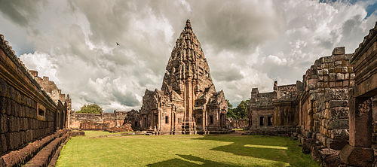
Phanom Rung temple
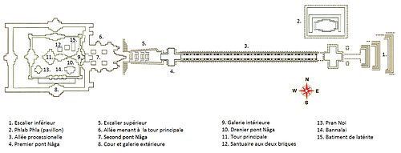
Layout of Phanom Rung temple
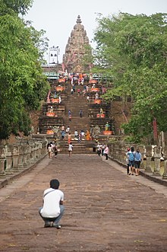
Phanom Rung castle pathway

Phra Narai Lintel
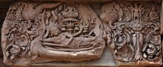
The Phra Narai Lintel
One of the most well-known elements of the temple is a decorative lintel placed above the eastern entrance to the central sanctuary. It depicts a reclining Vishnu or Vishnu Anantasayin, and is known in Thai as Thap Lang Narai Banthomsin (ทับหลังนารายณ์บรรทมสินธุ์).
The lintel is best known for its restitution from the Art Institute of Chicago in 1988. It had been stolen from the temple site in the 1960s and was acquired by the museum in 1967, where it was displayed for over twenty years, described as "the Birth of Brahma with Reclining Vishnu on a Makara". In early 1988, as restoration of the temple neared completion, calls were made by several parties in Thailand for its return. The issue became the subject of intense media attention, with some even accusing the US Government of facilitating the theft.^{[2]} The Thai government entered negotiations with the museum, which was unwilling to consider an unconditional return, since it had acquired the item in good faith. Finally, in October, the museum agreed to repatriate the lintel in exchange for a donation from the Chicago-based Elizabeth F. Cheney Foundation.^{[3]} The lintel's arrival in Thailand on 10 November was widely celebrated, and was covered live on the national TV pool. It was restored to its original position on 7 December, marking the completion of the temple's restoration.^{[4]}

References
  - Jump up^ "Phnom Rung Historical Park". Retrieved 9 Jul 2006. Printed by Joseph Plastic Crad (Korat) and Print Co. Ltd.
  - Jump up^ Crossette, Barbara (10 February 1988). "Thais Accuse U.S. of Theft Of Temple Art". The New York Times. Retrieved 7 January 2017.
  - Jump up^ "Chicago Museum to Return Lintel Thais Say Was Stolen". The New York Times. AP. 25 October 1988. Retrieved 7 January 2017.
  - Jump up^ Sukphisit, Suthon (9 November 2014). "A legacy set in stone". Bangkok Post. Retrieved 7 January 2017.

External links
- Nang Rong travel guide from Wikivoyage
- Official website, Thailand Fine Arts Department
- Phanom Rung Historical Park or Phanomrung Temple
- Khemita Visudharomn, Khmer Civilization in Isan

Khao Phra Wihan National Park

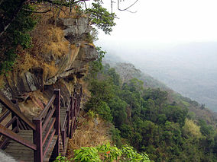

Khao Phra Wihan National Park (Thai: อุทยานแห่งชาติเขาพระวิหาร) is a protected natural area in Sisaket Province, Thailand, that contains numerous ruins of the 11th century Khmer Empire. The park lies 98 km (61 mi) south of the town of Sisaket, at the end of Thai highway 221. Sited on a red stone cliff that is part of the Dangrek mountain range on the southern edge of the Khorat Plateau, it abuts the international border between Thailand's Sisaket Province and Cambodia's Preah Vihear Province. The name of the cliff in the Royal Thai General System of Transcription is Pha Mo I Daeng (ผามออีแดง).

Contents
- 1Gateway to Prasat Khao Phra Wihan
- 2Dispute
- 3Nomenclature
- 4Pha Mo I Daeng
- 5Other sights
- 6See also
- 7Notes
- 8External links

Gateway to Prasat Khao Phra Wihan
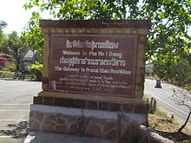
The park atop Pha Mo I Daeng is the Thai gateway to ruins associated with the temple of Prasat Preah Vihear, and is generally open to everyone upon payment of entrance fees. When relations between the two countries are normal, the temple ruins are also accessible from the Thai side. Both sides charge additional entrance fees for such access, but Cambodia does not require visas. Access from the Cambodian side is to the temple ruins only. The International Court of Justice awarded the temple ruins to Cambodia in 1962,^{[1]} but these are located in an area of 4.6 km² that Thailand still claims.^{[2]} Nevertheless, in 2008 the World Heritage Committee's 32nd Session listed the Temple of Preah Vihear as a UNESCO World Heritage Site,^{[3]} which prompted an armed dispute.
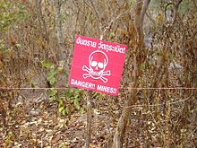
For visitors' safety, areas with landmines are clearly marked.

Dispute
Main article: Cambodian–Thai border dispute
In 2007, Cambodia proposed to the World Heritage Committee's Thirty-First Session that Preah Vihear Sanctuary be listed as a UNESCO World Heritage Site. As Cambodia and Thailand had not resolved border issues concerning the site, the Committee postponed consideration to its 32nd session, and asked Cambodia to provide a complete management plan for the area. Early in January 2008, Cambodia invited Thai experts to participate in a site survey of the Buffer Zone, and then to Siem Reap and Phnom Penh to collaborate with a team of international experts in the making of a plan for the area in Cambodian territory. Thai experts found "unacceptable scientific inaccuracies" in documents presented, dissociated themselves from the group, and then published in rebuttal their own Management Plan for Preah Vihear Mountain and Its Setting. A PDF English language version of the Plan has been released.^{[4]}
Following a February 2011 request from Cambodia for Thai military forces to be ordered out of the area, judges of the International Court by a vote of 11–5 ordered that both countries immediately withdraw their military forces, and further imposed restrictions on their police forces. The court said its ruling would not prejudice any final ruling on where the border in the area between Thailand and Cambodia should fall. It could take the court many months or even years to reach that decision.^{[5]} Abhisit Vejjajiva (caretaker Prime Minister since the just-concluded Thai general election, 2011) said that Thai soldiers will not pull out from the disputed area until the military of both countries agree on the mutual withdrawal. "[I]t depends on the two sides to come together and talk," he said, suggesting that an existing joint border committee would be the appropriate place to plan a coordinated pullback.^{[6]}

Nomenclature
The park takes its name from the Thai pronunciation of Khmer language Prasat Preah Vihear.
Prasat (ปราสาท) is from Sanskrit prāsāda “castle”. Both languages use Prasat to designate ruins resembling forts.
Preah and Phra (พระ) both are from Sanskrit varaḥ “excellent.”
Vihear is from Sanskrit/Pali Vihara (“temple” or its central structure.) Thai "วิหาร" may be transliterated as Viharn, but is pronounced and usually transcribed as Wihan.
Khao (เขา) is Thai for a mount, mountain, or hill ("phnom" in Khmer; Cambodians may say "Phnom Preah Vihear".^{[7]}) เขาวิหาร may be translated into the English language as Temple Hill.^{[8]}

Pha Mo I Daeng
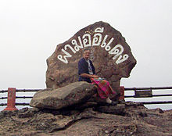
Pha (ผา) is a cliff, crag, rock or tor
Mo (มอ) pronounced like English "maw" with an even tone means gray or gloomy.^{[10]} (Royal Institute Dictionary 1982 edition “mo” definition 4: [qualifier] blurred, such as mountains obscured darkly (มอ ๔/มอ/[วิเศษณ์] สีมัว ๆ อย่างสีดำเจือขาว.)
I (อี) pronounced like English "ee" is a designation for one without customary restraint[
Daeng (แดง) is red.
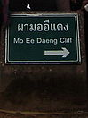
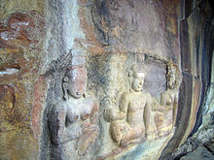
Mo Ee Daeng Cliff rears over 500 metres above the Cambodian plain. In 1987, a Border Protection Ranger Unit discovered two groups of bas-relief images and engravings. The Management Plan says on p. 14, "Based on iconography, the figures are dated circa 10th century, or older than Preah Vihear Temple." The figures are now a highlight of the park. Some parts have flaked off, so the area is barred behind a gate. A staircase leads down to the gate, where the images are clearly visible.

Other sights[edit]
The park is covered by dry evergreen forest, mixed dipterocarp forest, and deciduous dipterocarp forest with tree species like Pterocarpus macrocarpus, Shorea siamensis and Xylia xylocarpa var. kerrii. It is home to numerous wildlife which roams between two countries such as wild hog, deer, barking deer, rabbit, squirrel, gibbon and civet.
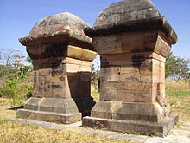
Twin Stupas
'Twin Stupas. The Twin Stupas are two red sandstone structures, 1.93 m. square and 4.20 m. high, with lotus-bud-shaped apices.
Don Tuan Khmer Ruins. Built during the 10th -11th Century, the Khmer Ruins near Ban Phume Sarol (บ้านภูมิซรอล) are located at 14°24′26″N 104°44′45″E, 350 meters onto the Cambodia side of the distinct watershed border ridge, at an elevation of 250 meters above sea level, 30 meters below and 350 meters southwest of the border ridge. The only road access, however, is from Thailand. Legend tells that in the past a lady known as Nang Nom Yai or Nieng Non dor (in Khmer), stopped to rest here on her way to visit a king.
Namtok and Tham Khun Sri. The three-tiered waterfall, above the cave, is situated west of Sra trao close to trail to Phreah Vihear. Khun Sri Cave is of gigantic proportions and was believed to have been the accommodation of Khun Sri, a noble man who controlled rock cutting at Sra Trao at the time of the construction of Preah Vihear Sanctuary.
Namtok Phu La-Ō (น้ำตกภูละออ). Situated in Phanom Dongrak Wildlife Sanctuary, Tambon Sao Thongchai, the small waterfall turns vibrant during September to February.

See also
- Cambodian–Thai border dispute
- Preah Vihear Temple
- Irridentism

