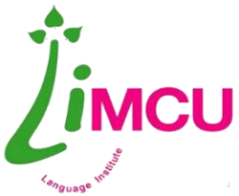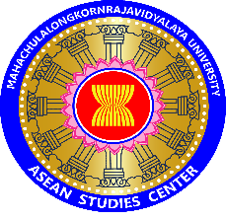

ASEAN 4.0 Academic Writing Project (Short Term Course)
Program: 30 June – 2 July 2018 (B.E. 2561)
Wat Ananda Metyarama (Thai Buddhist Temple in SG)
30 June 2018 Saturday (Day 1)

05.40 AM | Meet at Don Meaung International Airport
07.40 – 10.20 AM | Thai Lion Air, SL __
11.30 – 13.00 PM | Lunch @ Changi Airport Terminal (self-service)
13.00 – 14.00 PM | Bus to Wat Ananda Metyarama – check in and rest
14.00 – 16.00 PM | National Gallery of Singapore
16.00 – 18.00 PM | Asian Civilizations Museum
18.00 – 18.45 PM | Library@ Esplanade (Theatres on the Bay)
18.45 – 19.30 PM | Merlion Park

1 July 2018 Sunday (Day 2)

5.45 – 6.25 AM | Wake up
6.30 – 7.30 AM | Morning Chanting (compulsory for all according to CK Rian)
7.30 – 8.30 AM | Participant Group: Breakfast @ Wat Ananda  Non-participant Group: Breakfast (packed) @ Botanic Gardens
8.30 – 11.00 AM | Participant Group: Workshop @ Wat Ananda on “Writing Academic English” by Ajahn Huiling
11.00 – 12.30 PM | Lunch @ Wat Ananda  Rest
12.30 – 15.00 PM | Sri Lankaramaya Buddhist Temple (primary temple) Burmese Buddhist Temple (oldest temple)
15.00 – 16.00 PM | Buddha Tooth Relics Temple & Museum
16.00 – 17.00 PM | Shopping @ Chinatown – food and souvenirs
17.00 – 20.00 PM | Gardens by the Bay  Marina Bay Sands
2 July 2018 Monday (Day 3)

5.45 – 6.25 AM | Wake up
6.30 – 7.30 AM | Morning Chanting (compulsory for all according to CK Rian)
7.30 – 8.30 AM | Participant Group: Breakfast @ Wat Ananda  Non-participant Group: Breakfast (packed) @ Mount Faber
8.30 – 11.00 AM | Participant Group: Workshop @ Wat Ananda on “Writing Academic English” by Ajahn Huiling
11.00 – 12.30 PM | Lunch @ Wat Ananda  Rest
12.30 – 15.00 PM | National Museum of Singapore
15.00 – 16.30 PM | Shopping @ Mustafa – electronics and gadgets
16.30 – 17.30 PM | Back to temple  Rest, shower, pack up and check out
17.30 PM | To Changi Airport @Thai Lion Air, SL ___

Note: Schedule is subject to change as appropriate

